**Final Project Execution Document**

**AtomCamp-Cohort-2**

1. **Dataset used was a copy get from kaggle.com with less number of records:**

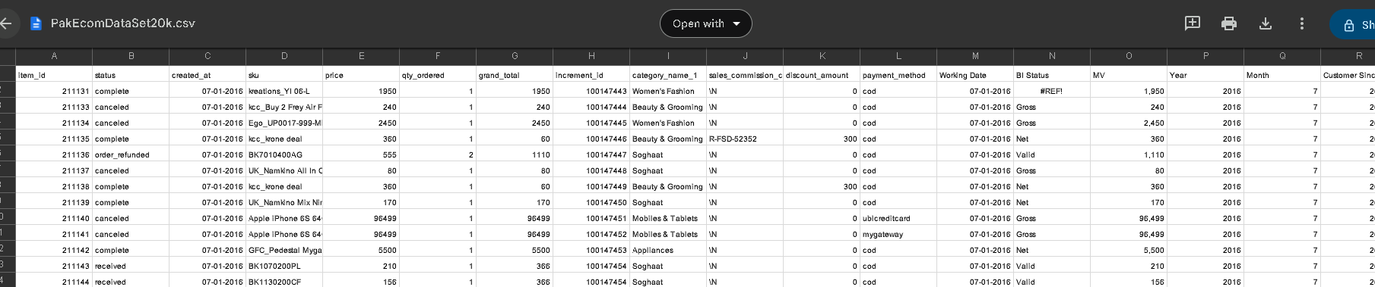

1. **PART-1: Result after executing data_cleaning.ipv**

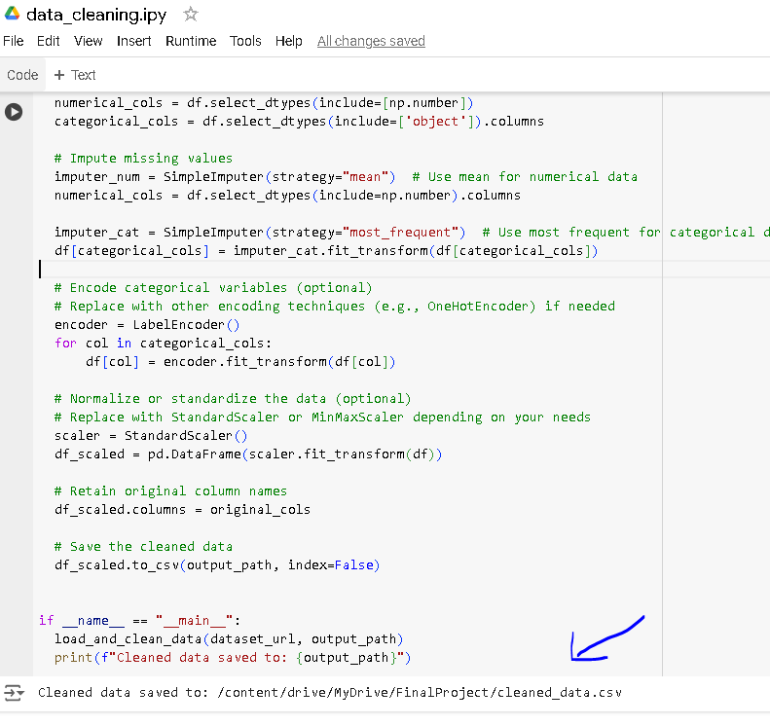

1. **CleanedDataSet shows successful conversion ML Model used**

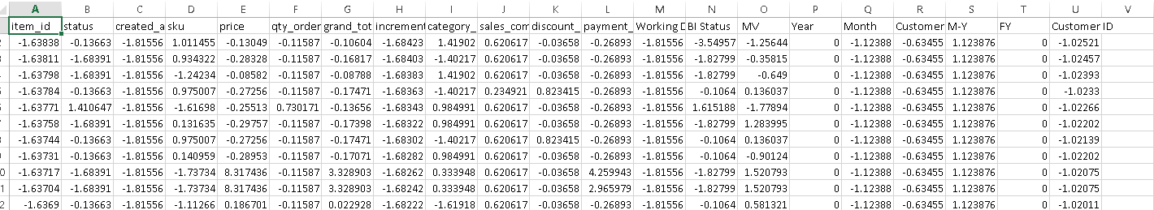

1. **PART-2: Result of Executing Model_building.pv: Successful execution is recorded as under:-**

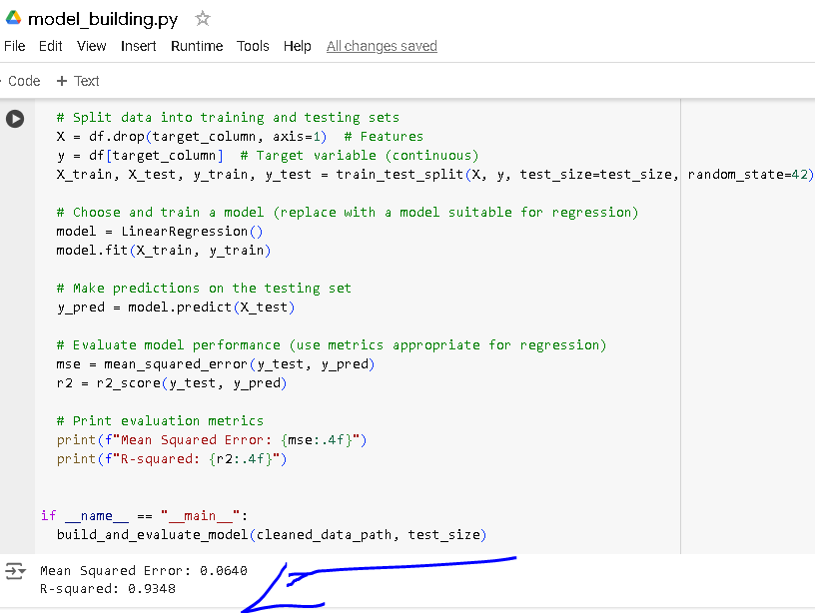

1. **PART-3: EXECUTION RESULT FROM MODEL LOADING AND SAVING: Model_io.pv- Successful**

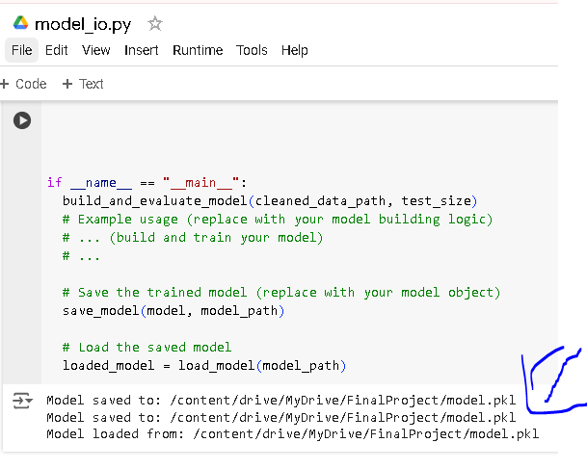

1. **FastAPI Endpoints- Successful**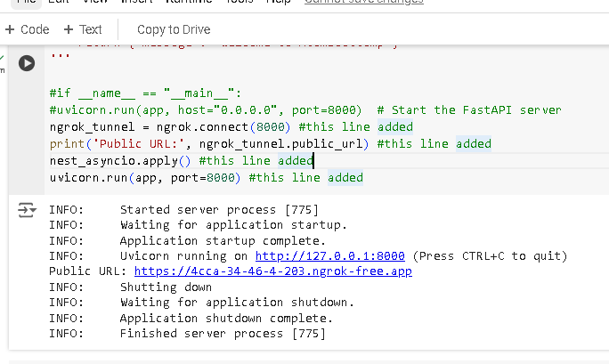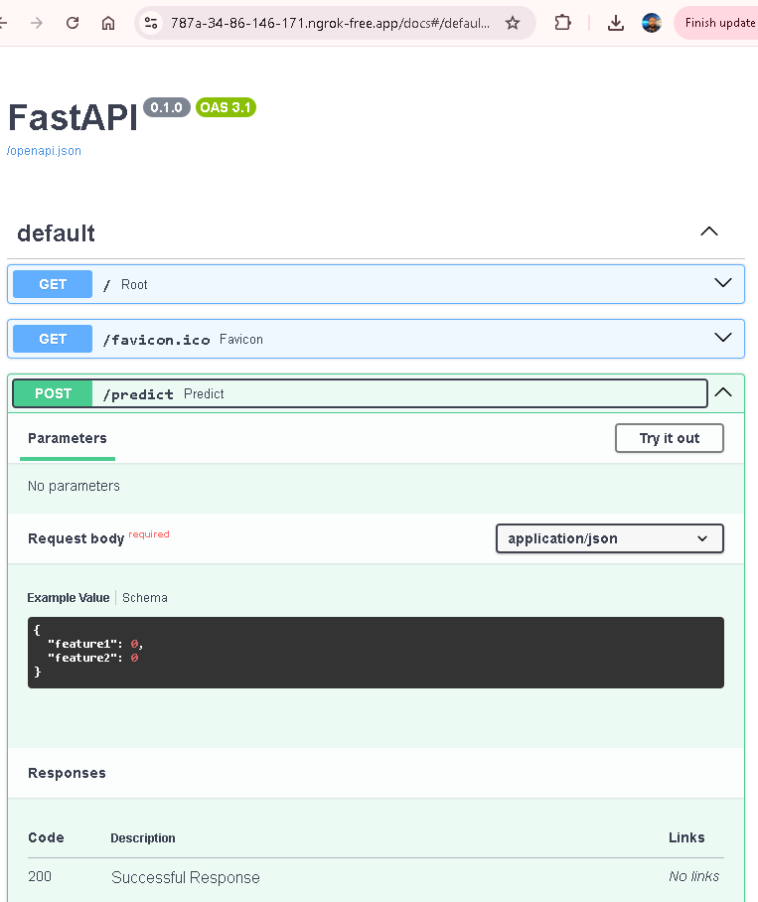

**Note:**

This FastAPI endpoint was not properly giving prediction output, might be due to the prediction model used or some dataset related issue. The matter was discussed with concerned resource person, progress was mind as per guidance.

1. **STEP-5: Part 5: Deployment at Hugging Face with a Simple UI using Gradio-Success**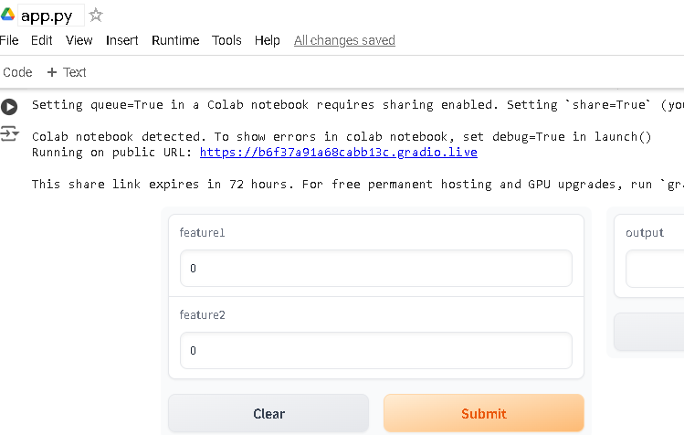
2. Uploading on Github Repository